**New Elevator Installation Record:**

During application process user will manually create a New Elevator Installation record.

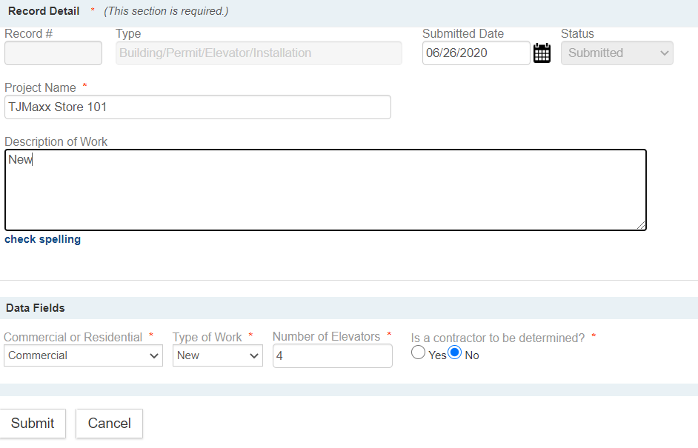

After the Submit button is selected an Administrative Fee with a Qty of 1 and Fee of $57 will automatically be added.



During application process user will manually update the Elevators Table.

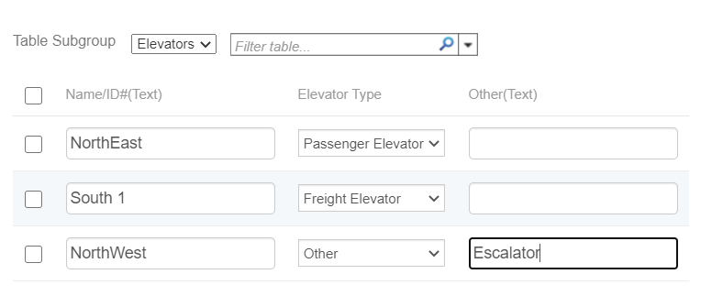

Before Permit Issuance: Fees must be paid, Address, Parcel and Owner are required. Additionally, the Number of Elevators in Table must match the Number of Elevators field. If not, an error will display indicating missing information.

When the Workflow Task 'Certificate of Inspection' Status is updated to 'Completed' and the Custom Data Field 'Commercial or Residential' is 'Commercial' then a script will automatically do the following:

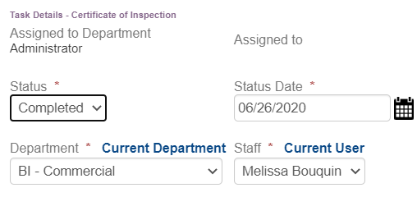

**Elevator Master Record:**

1. Create a related 'Building/Permit/Elevator/Master' Record as the Parent with the Address, Parcel, Owner, Project Name, Elevators Table and Permit Expiration Date field.

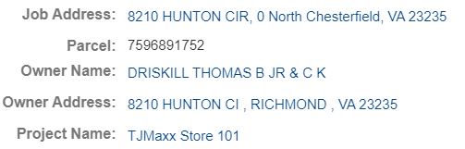

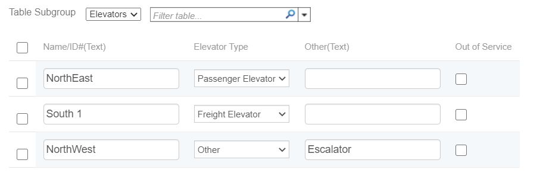

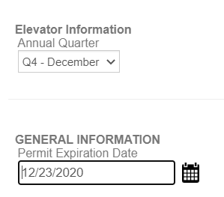

* 1. Update Workflow Task 'Annual Status' to 'In Service' and Record Status to 'Active'.



* 1. Update Quarter based on Permit Expiration Date - previous 2 months and current month.



1. Update the related Building/Structure/NA/NA Record ‘Elevators’ Table to match Installation ‘Elevators’ Table.

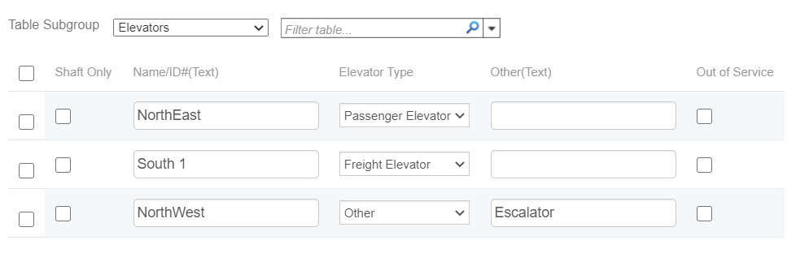

**An automatic Batch Script on Building/Permit/Elevator/Master Records based on Quarter.**

* Quarter 1 runs on what Dec 1 of every year.
* Quarter 2 runs on March 1 of every year.
* Quarter 3 runs on June 1 of every year.
* Quarter 4 runs on Sept 1 of every year.

When Building/Permit/Elevator/Master Records ‘Quarter’ field matches date run above then

1. Set the Workflow Task ‘Annual Status’ to Status of ‘Annual Renewal'.
2. Set the Record Status to 'Active-Pending Renewal'.

A new Task Management Filter will be available to select ‘Annual Renewal’ Elevators.

A new Record List Filter will be available to select ‘Active-Pending Renewal’ Elevators.

User can manually update the Elevator Master record based on filter above. Contacts can be added, Elevator Table can be updated if Out of Service.

A Script will automatically update Structure Elevator Table if updated by user on the Elevator Master record.

**New Elevator Renewal Record:**

A Script will automatically create the Renewal Record based on a Workflow Task Status of ‘Pending Renewal’

The Renewal Record will be a cloned from the Elevator Master Record as a Child.Copying the Address, Parcel, Owner, Contacts, Project Name and Elevators Table.

The Annual Certificate of Compliance Fee will automatically be added based on Number of Elevators that are ‘In Service’ as the Qty.



Before Workflow Task ' Renewal Issuance' is 'Renewed' Fees must be paid. If not, an error will display indicating missing information.

When Workflow Task ' Renewal Issuance' is 'Renewed' then a script will automatically do the following:

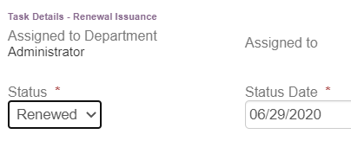

1. Update the related 'Building/Permit/Elevator/Master’ Record Owner, Project Name, and Elevators Table and Permit Expiration Date field to the next year (do not update day or month).







* 1. Update Workflow Task 'Annual Status' to 'In Service' and Record Status to 'Active'.



1. Update the related Building/Structure/NA/NA Record ‘Elevators’ Table to match Renewal ‘Elevators’ Table.

